# Assignment-1 SQL Commands

**Q1. Create table Student (Rno, Name, DOB, Gender, Class, College, City, Marks) .**

**Ans1- Create table Student(Rno int , Name Varchar(20) , DOB Date , Gender Varchar(20) , Class Varchar(10) , College Varchar(20) , City Varchar(20) , Marks int);**

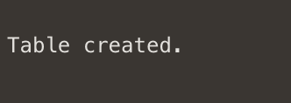

**Q2.** **Insert 5 records in student table.**

**Ans2-**

**insert into Student values(1 , 'Manan Mehra' , to_date('28-OCT-2002','DD-MON-YYYY') , 'male' , '2co8' , 'thapar' , 'delhi' , 99 );**

**insert into Student values(2 , 'Sai Manav Bhargav' , to_date('10-OCT-2002','DD-MON-YYYY') , 'male' , '2nc8' , 'thapar' , 'dehradun' , 100 );**

**insert into Student values(3 , 'Urvi Garg' , to_date('27-JUN-2003','DD-MON-YYYY') , 'female' , '2ec8' , 'thapar' , 'patiala' , 97 );**

**insert into Student values(4 , 'Pretty Goel' , to_date('30-NOV-2002','DD-MON-YYYY') , 'female' , '2nc8' , 'thapar' , 'amritsar' , 35 );**

**insert into Student values(5 , 'Vasu Agarwal' , to_date('23-JAN-2003','DD-MON-YYYY') , 'male' , '2nc8' , 'thapar' , 'najibabad' , 77 );**

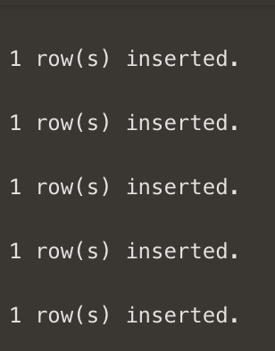

**Q3. Display the information of all the students.**

**Ans3- select * from student;**

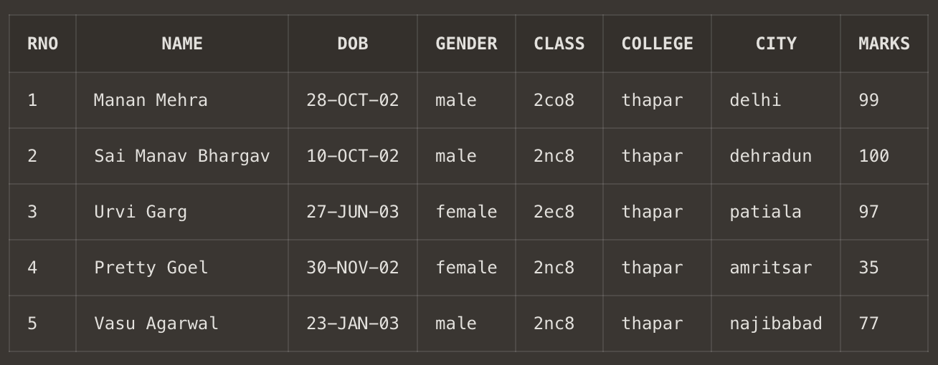

**Q4. Display the detail structure of student table .**

**Ans4- decribe student;**

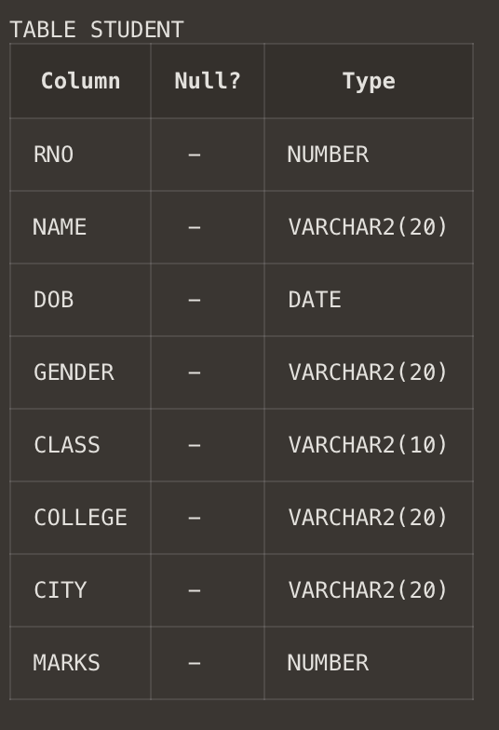

**Q5. Display Rno, Name and Class information of ‘Patiala’ students.**

**Ans5- select Rno, Name ,class from student where city='patiala';**

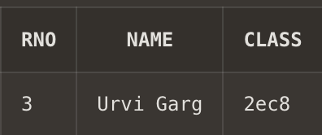

Q6. **Display information on ascending order of marks**

**Ans6- select * from student order by marks;**

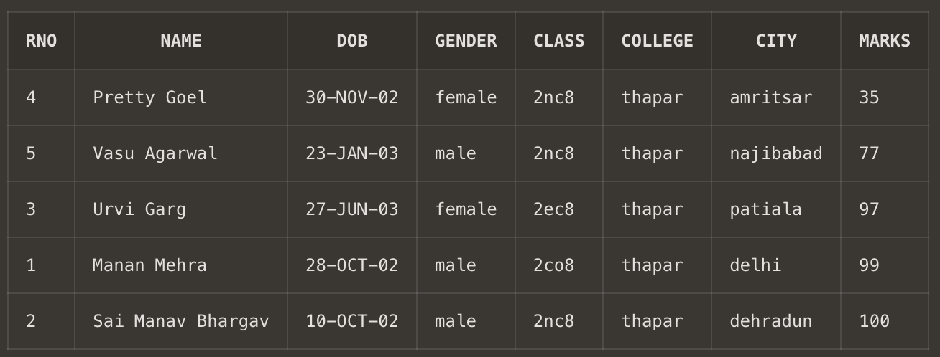

**Q7. Change the marks of Rno 5 to 89.**

**Ans7- update student set marks = 89 where Rno = 5;**

**select * from student;**

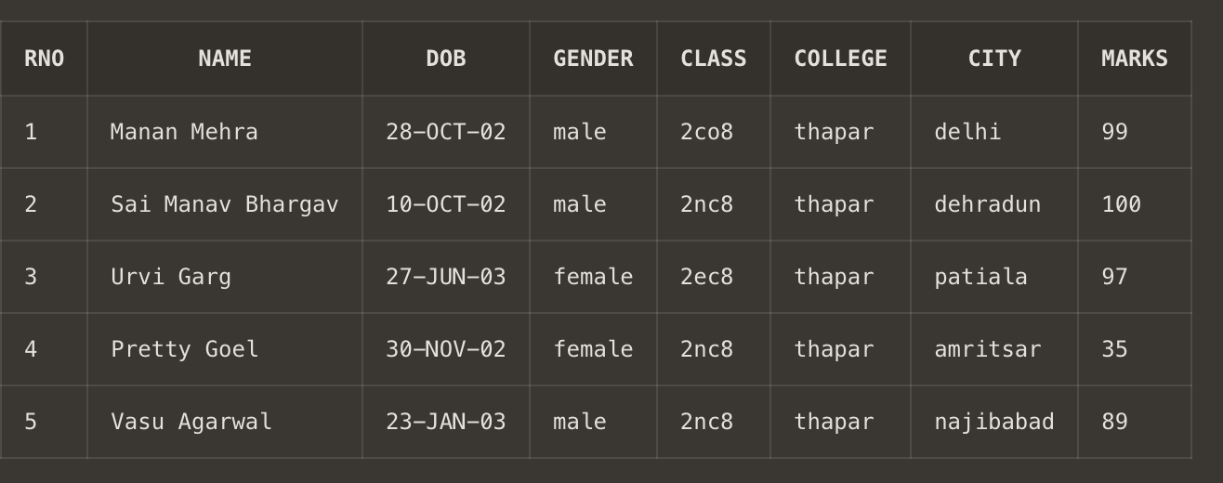

**Q8. Change the name and city of Rno 4.**

**Ans8- update student set name = 'Shorya Agarwal' , city = 'najibabad' where Rno =4;**

**select * from student;**

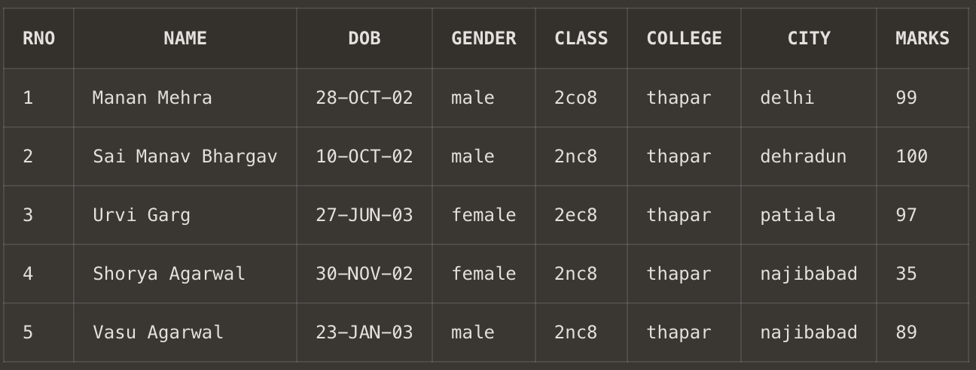

**Q9. Delete the information of ‘Amritsar’ city records**

**Ans9- delete from student where city = 'amritsar';**

**select*from student;**

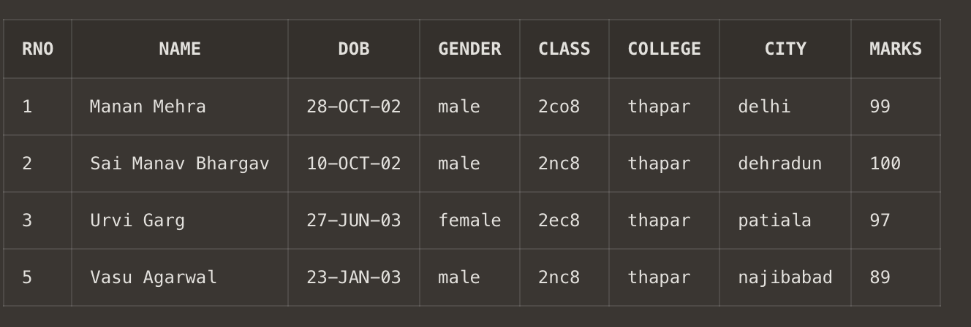

**Q10. Delete the records of student where marks<30.**

**Ans10. delete from student where marks<30;**

**select * from student;**

